1. Agenda:
   1. How to simulator a server error (5xx) using wiremock.
2. 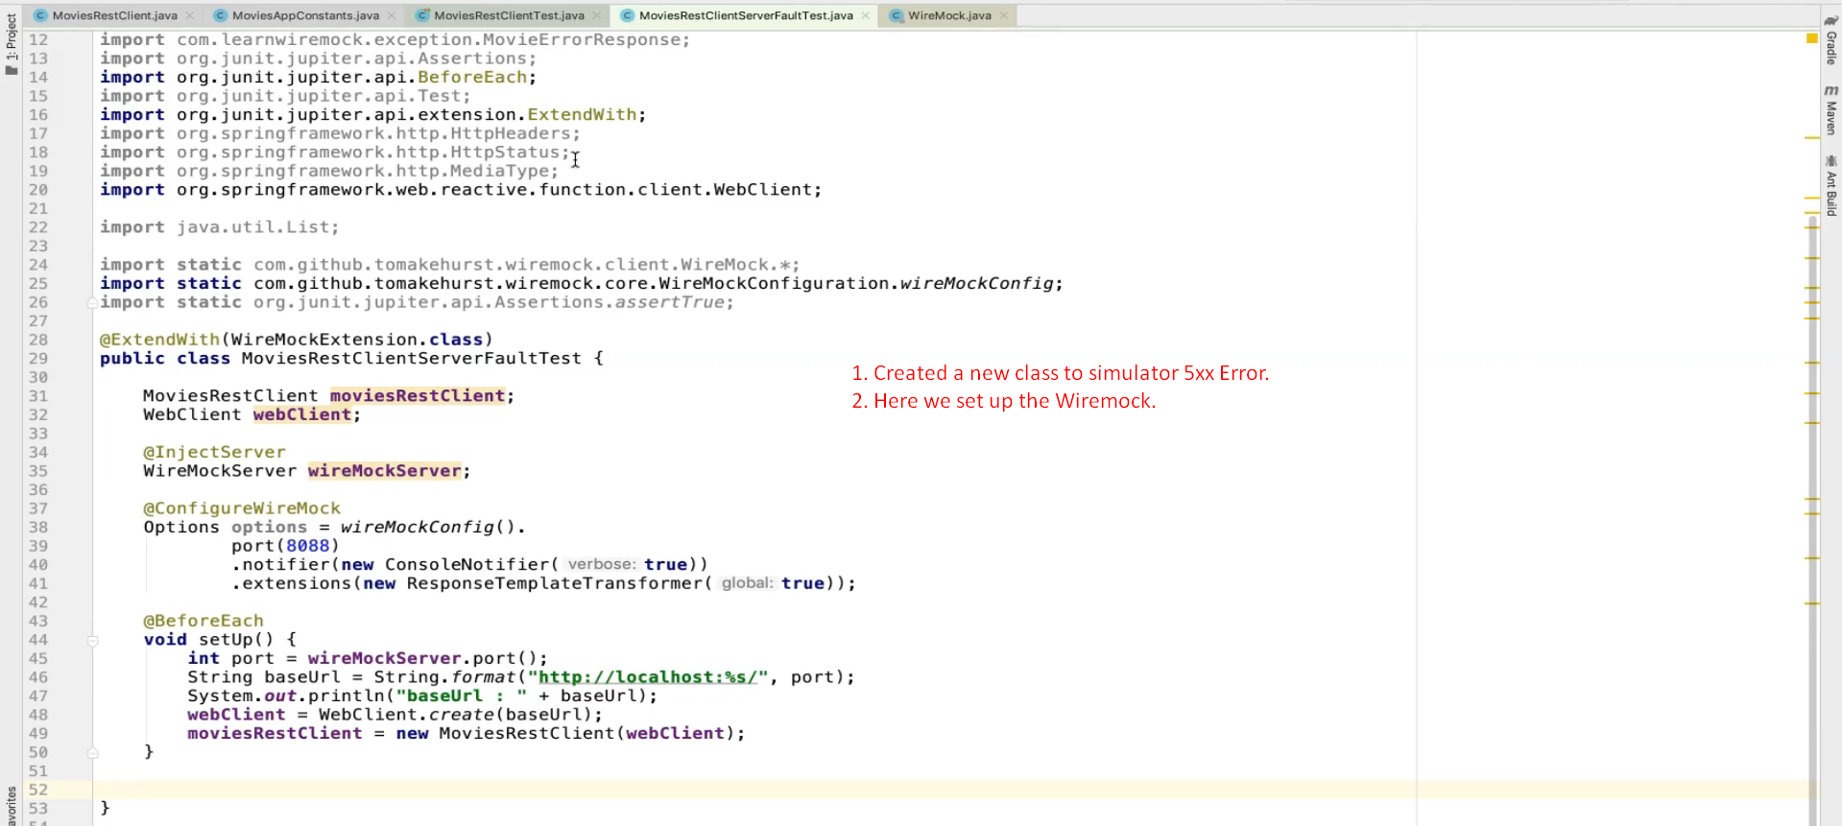
3. 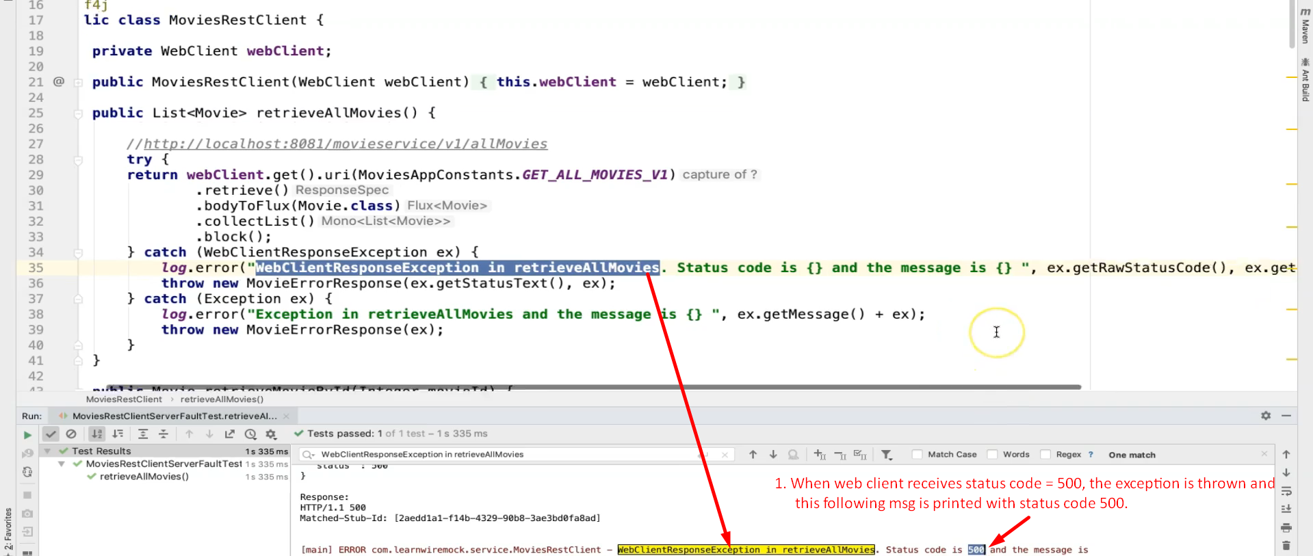  
   Also note that the catch block is throwing 🡪 throw new MovieErrorResponse(). Check.
4. 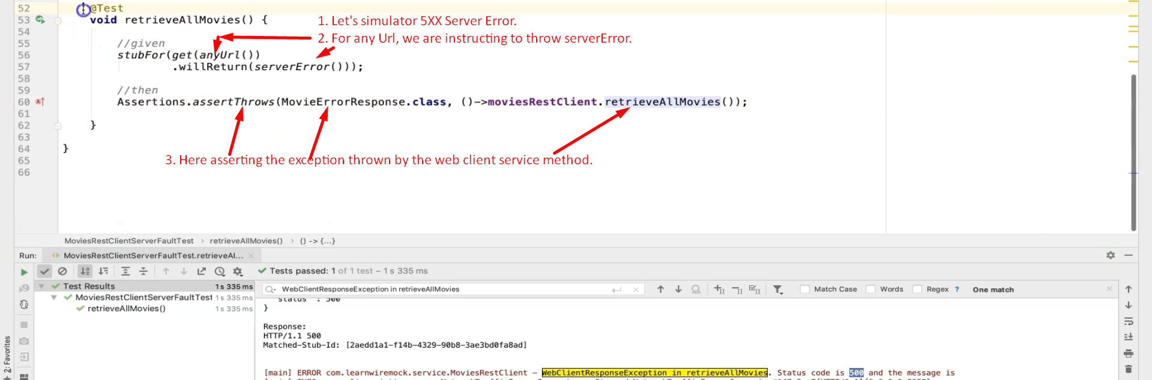  
   NOTE: By default serverError() set up the HTT Status code = 500.  
   Let’s change it.
5. 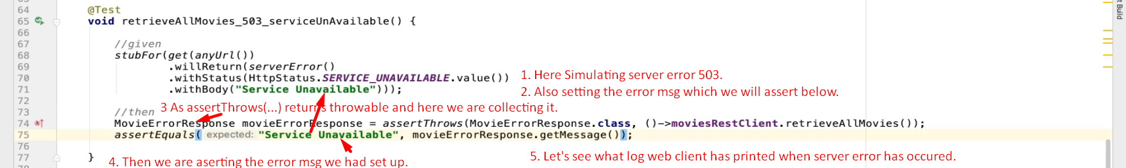
6. 